1. 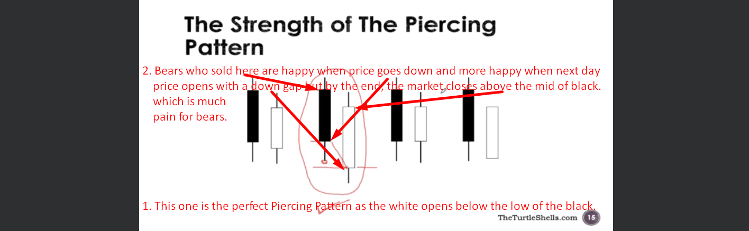
2.   
   A graph with red lines and arrows

   Description automatically generated with medium confidence
3. A graph with a line graph

   Description automatically generated with medium confidence